**Shikkha Sheba  
Business Requirements Specification**

|  |  |
| --- | --- |
| **Submitted by:** | **Submitted to:** |
| 95 Bir Uttam AK Khandakar Rd,  Dhaka 1212, Bangladesh | https://lh3.googleusercontent.com/proxy/ptTbor2Rei7AJNAuIrdIqdgRW1nOrd9PxM9vqxb9QxiaXwMMo-cDvtg0kTJmo6wRsVmj7-4mRv28EImgTMhO_qAH1YgbKHwI  House 55, Road 4/A, Dhanmondi R/A  Dhaka 1209, Bangladesh |



**Table of Contents**

**1.** **Project Background** 2

**1.1** **Objectives** 2

**1.2** **Current Situation** 3

**1.3** **Proposed Solution** 3

**2** **Project Scope** 4

**2.1** **Scope of Work** 4

2.1.1 Non-Functional Requirements 10

2.1.2 Development Environment 11

**2.2** **Methodology & Implementation Approach** 12

**2.3** **Project Constraints** 12

**3** **Quality Control Measures (Review and Testing Process)** 14

**3.1** **Review Process** 14

**3.2** **Testing Process** 16

**4** **System Architecture** 17

**5** **User Story** 18

**5.1** **Training Module** 18

5.1.1 As an Admin 18

5.1.2 As a Trainer 30

5.1.3 As a Participant 38

**5.2** **Assessment Module** 47

5.2.1 As an Admin 47

5.2.2 As a Trainer 55

5.2.3 As a Participant 59

**6** **Solution Process Flow** 65

6.1 Training Module 65

6.2 Assessment Module 66

**7** **Proposed Team Members** 67

# **Project Background**

Shikkha Sheba has come up with initiatives to build up a platform where students of different levels including University, A-Level and O-Level etc. would be able to get academic guidance and support from corresponding supervisors. Moreover, since the global pandemic, LMS has likely become one of the most useful tools for any academic institution.

Such requirements emerged the need of a consolidated Learning Management System.

## **Objectives**

In this era of science and technological advancement, the COVID 19 outbreak has left unprecedented impact in the human life. It has adversely affected student’s life from almost all the levels.

Shikkha Sheba LMS can rest down the hassles that students face while seeking a suitable online training/ learning platform in the right manner.

The proposed solution will be wrapped with some essential features and functionalities through automation, and tracking.

The objectives of this project depicts the following points:

* Full analysis of the processes and identify existing issues or potential blockers.
* Full analysis of existing processes and potential risks for the time taken to complete the process.
* Full analysis of timings and volumes of current scope.
* To produce recommendations for both short- and long-term improvements to be discussed and agreed with relevant stakeholders.
* To drive recommendations through implementation, with assistance from the business.

## **Current Situation**

Currently Shikkha Sheba does not have any solution ready to enable distant learning for academics.

Shikkha Sheba has already equipped the learning panel with experienced teachers and qualitative teaching contents. Mock questionnaires, training videos are also aligned to be served through a learning management system.

A consolidated platform would be required to suffice necessary requirements of Shikkha Sheba to go online teaching.

## **Proposed Solution**

The proposed Learning Management Solution will be strengthened by two major modules:

* Training Module;
* Assessment Module;

The system can be accessed by designated administrators, trainers and participants who would be enrolling in the courses that are built up by trainers. Participants will also be able to participate in specific types of assessment tests to assess course centric competency. Trainers will be able to design the assessment tests as well.

Based on a learner’s competency one would be awarded with relevant certification or would be provided with subject specific improvement plan.

Detailed features upon this solution are listed in solution’s scope of work.

# **Project Scope**

## **Scope of Work**

|  |  |
| --- | --- |
| **Landing Page** | **Separate Profile Landing page for each User Types.** |
| Trainers |
| Participants |
| Admin |
| **Main Landing Page (for all)** |
| Popular/Available Courses in Landing Page: Based on Enrollment count, Popular Training will be shown. If count is same then alphabetical order. |
| Upcoming Courses in Landing Page: Based on Course start date that is greater than current date will come to Upcoming courses section. |
| Web pages/UI will be Multilingual (Need list of specific sections to be multilingual) |
| **Training Module** | **Calendar view and Scheduling option for trainers** |
| **Course Builder** |
| Training courses will have specific Start Date, End Date, Total capacity; |
| Each Course can be plotted following particular curriculum; |
| A course can have multiple batches |
| * The curriculum structure will be as follows:   1. Syllabus (A Levels/ O Levels/ Etc.)      1. Subject (ex. English, Bangla, Physics, Chemistry, etc.)         1. Each subject can have multiple batches;         2. A batch can contain several classes:   Topic/Chapter can be appended with each class rubric  Contents (Live Streaming, Video recordings, Reading materials) can be incorporated with class materials; |
| There will be option for upload thumbnail image and video of the Course (to be shown in Landing page) |
| Option to save a course will be available. |
| There will be option Schedule classes on future dates. |
| **In a Particular scheduling unit (hour, day, week, month) there can be several activities as follows,** |
| * **Live Online Class** |
| * **MCQ quiz** |
| * Design Question and Multiple choices and Correct answers from Trainer's "My Questions" section |
| * Set Duration |
| * Design Quiz by Tagging Individual MCQ |
| * Tag Quiz (MCQ) in Day from Course Builder. |
| * **Descriptive Question** |
| * Design descriptive Questions from Trainer's "My Questions" section |
| * Set Duration |
| * Design Quiz by Tagging individual Descriptive Question. |
| * Tag Quiz (Descriptive) in Day from Course Builder. |
| * **Provide Reading materials (pdf, MS Office documents), Video contents.** |
| * **Assignment (feedback file) to be submitted by Participant within a Due date and time defined by Trainer.** |
| **Segment wise Video for uploaded class videos.** |
|  |
| **Assessment Module** | **Assessments** |
| **Assessment of current skills:** |
| Technical Skills Assessment Test: The learners will appear at psychometric tests against fixed sets of questions and will be scored based on their performances and tests' results. The tests will be categorized into three distinguished categories such as beginner, intermediate and advanced. Each of these categories will enable three different levels of people to judge their current skills. Such as beginner test for novice/early career professionals, intermediate test for mid-career professionals and advanced level test for professionals who have walked a long way in their career. |
| Soft Skills Assessment Test: Learners/professionals will also appear at soft skills tests in the similar way and receive a test score afterwards. |
| Interest based Psychometric Test: Learners/professionals will also be able give Psychometric Test to understand their interest and hidden potential. |
| Participants will also be joining Regular/Job type assessment tests; |
| These individual scores will be stored in the learners' personal database against their account. |
| **Improvement Plan** |
| Participants will get improvement plans created by trainers if they find themselves weak in assessment’s performance; |
| Improvement plans will be set by Admin; |
| Participants can request for time extension to admin to complete improvement plan; |
| **Results** |
| •         Dashboard for displaying of the assessment result |
| •         The test results of the learners will be stored under a separate section in the  dashboard. |
| **Participant Journey** | After Successful signup, Participant have to fill up their Profile like a CV with Personal, Educational, Professional, Interest information. |
| Participants cannot enroll any Course until their Profile (CV) is incomplete (Completeness will be considered >= 60%). |
| Participant will get and become enrolled from Available Course section. |
| From the section of Enrolled Courses, Participant can see day wise activities of a Course, designed by Trainer. |
| Based on profile information, Available Courses will be populated. |
| Participant’s calendar view.  On missed classes, participants can join any time on clicking the date from calendar. |
| Participants will get day wise contents from enrolled courses. |
| Participant of that specific course who have enrolled, will receive SMS, Email and in-Panel notification of the Activities in a day will be defined and On any changes. |
| **Class Resource/Material** |
| For each Video content while participant watching for 1st time they cannot skip or fast-forward. |
| If student missed the class, they can join any time on clicking the date. |
| Participant can view Reading material and Video content from the day wise activities in their enrolled courses. |
| Downloadable contents can be downloaded from the section of Enrolled Courses, in day wise activities of a Course. |
| **Participate Quiz:** |
| Participant will conduct quiz from their Profile>My Courses>Day wise Class |
| There are 2 types of Quiz, whether MCQ or Descriptive. For both there will be timer function where always view the remaining time of the quiz will be visible. |
| MCQ Quizzes will be checked by System and the result/score will be reflected in Trainer's profile automatically. |
| Descriptive Q/A will be checked and put marks manually by Trainer and the answers from each Participants will be reflected in Trainer's profile automatically. |
| **Conduct Assignment:** |
| Participant will provide Assignment (feedback file) from their Profile>My Courses>Day wise Class where assignment has been defined. Which can only be submitted within a Due date and time defined by Trainer. |
| **Wish List** |
| Participants can add Courses in their wish list. |
| Course wish list view |
| Remove from course wish list |
| **Participants can save class lessons from a particular course.** |
| **Learning Streak (Activity Tracker)**   * Participants can track and evaluate own progress in a program. |
| **Identify individual position/rank amongst total participants’ attended at the test.** |
| **Live Mock Test**   * Participants can perform live mock test; * Participants can view test analysis result of each mock test; |
| **Quiz centric combat & reward** |
| **Content Vault** | There will be an Upload screen for Training Content |
| Contents can be uploaded to Content Vault;  While creating course contents can be attained from content vault; |
| After uploading content by Trainer, Admin have to approve. After approval done, the content will be displayed to the trainer in the course builder page and participant's Enrolled Course page. |
| Contents like reading material and videos can be defined as downloadable or readable in Course builder. |
| While designing a course in course builder, trainer have to select the pre-uploaded contents from Content Vault. Which means, before assigning Contents in courses that has to be uploaded first and approved in Content Vault. |
| **Certificate** | Certificate will be generated by system on given template. Course Title, Participant Name will be generated by system Dynamically. |
| Create Certificate template for Training courses |
| **Live Class Session** | Generate Link of the session |
| Join/create training/meeting through API from our Training Module (generate current and also scheduled meeting URL). |
| One way communication from Teacher to Student. Students feed from web camera/smartphone will not be established. |
| From live class download lecture contents with or without annotation. |
| Audio & Video Recording (Store video after training/live to media vault) |
| Separate view for tutor screen and presentation slide. |
| Interactive class works through chat window. |
| Web surfing / Video Streaming from uploaded media vault |
| Restrict training/live class URL with separate URL/ auth and also ensure single simultaneous access |
| **Payment Module** | * Integration with payment gateway. * Payment Type / Monthly Subscription: * Free * Paid * Payment History * DUEs |
| **Admin Module** | Sign up |
| Login |
| Logout |
| **User Management** |
| Add/Create User |
| List Screen of all User's |
| Edit/Delete User |
| **Role Management** |
| Add/Create Role |
| List Screen of all Roles |
| Edit/Delete Role |
| Assign/Remove Permissions on a Role |
| List Screen of Assigned Permissions on a selected Role |
| **OTP Management** |
| Integrate SMSC API |
| OTP generation process |
| OTP expiration process |
| OTP validation process |
| Token cleanup process |
| **Administrative Control** |
| Admin will create Master data for Syllabus/ Subjects. |
| Admin will approve the Content upload transaction initiated by Trainer. |
| After publishing Course by Trainer, Admin have to approve. After approval done, the course will be displayed to the Participants in the Landing page. |
| Admin will see the Course in detail before Approval. |
| **Course Feedback** |
| For every Course, Admin will take an Assessment session with Participants except Trainer's presence. Course Feedback questionnaires cannot be modified by Admin. |
| Admin will only initiate Course Feedback with effective date from Admin Panel |
| **Notification Service** | Service Development and Integration |
| Email / Text notifications to participants; |
| Notifications to administrators on participant’s course progress status. |

### Non-Functional Requirements

**Usability Requirements**

* User friendly Graphical User Interface (GUI);
* Easy navigation;

**Reliability Requirements**

* Precisions should be appropriate all over the queries/calculations;
* Strong role based functionality access security mechanism;
* Data consistency will be provided across the application;
* Proper data validation will be there;

**Performance Requirements**

* Quick report generation facility;
* Process time will be optimum;
* Appropriate messaging will be there;

**Design/Technical Requirements**

* RDBMS will be decided after getting approval from authority;

**Backup/Recovery Requirements**

* Store detail data generated by each user;
* Recovery mechanism will be from the backed up data files in case of any disaster;

### Development Environment

|  |  |
| --- | --- |
| **Middleware** | Laravel |
| **Web** | React JS |
| **DB** | Maria DB (latest) |
| **Plugins** | Redux, Reduces |
| **Caching** | Redis |

## **Methodology & Implementation Approach**

The implementation approach is designed to focus on People, Process, and Technology and to provide consolidated solution. For delivering the services, agile methodologies on SDLC processes are proposed.

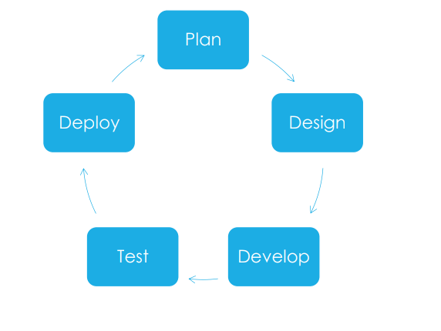

## **Project Constraints**

|  |  |  |  |
| --- | --- | --- | --- |
| **SL.** | **Risk Type** | **Description of Risk** | **Mitigation Action** |
|  | Technical Risk | * Endless changes of requirements for the software * Existing technology required for the development is only in its initial stage with no advanced technology being available * The project is too complex to implement * Integration of modules turns out to be too much of a challenge within the project performance | * Resolving design problems with the client when they arise * Reviewing product design with the client * Involving the client in decisions related to product design * Skill centric expertise generation |
|  | Project Management Risk | * Failure in addressing priority conflicts * Failure in resolving the responsibilities of each member of the team * Insufficient resources for project or software development * Skills for subject training are not aligned * Resource planning is overlooked * Lack of communication among team members | * Create a project risk register. * Identify project risks. * Identify opportunities. * Determine likelihood and impact. * Determine the response. * Task Completion Estimation. * Assign owners. * Regularly review project risks. |
|  | Schedule Risk | * Time is not estimated properly for the project * Staff, skills, and systems are not tracked properly * Functionalities for the software are not identified in a timely manner that results in affecting the time required for developing these functionalities * Project scope expansions come up unexpectedly | * Reduce the number of Critical Paths * Reduce Activity Dependencies * Schedule Risky Activities Earlier * Plan Regular Schedule Reviews |
|  | Budget Risk | * Budget estimation is incorrect * Cost overruns occur without realizing the need for reserved funds * Project scope expansion * Resource estimation is incorrect | * Monitor costs and commitments of large and high-risk incentives. * Share timely information on incentives across relevant agencies. * Link incentives to company performance. * Require businesses to provide advance notice of program participation. |

# **Quality Control Measures (Review and Testing Process)**

The functional decomposition diagram of Review and Testing process is shown below.

Review and Testing Process

Review Process

Testing Process

Review of PMP

Review of BRS

Review of UI/UX Design Documents

Review of Test Case

System Testing

Acceptance Testing

Unit Testing

Integration Testing

Review of Source Code

Review of Test Result

Review of User Manual

Review of other Work Product

Regression Testing

## **Review Process**

**Review of BRS**

The objective of this sub-process is to review detailed business requirements specification as described in BRS. Activity includes verification of customer requirements as per actual requirements obtained from customer.

**Review of Project Management Plan**

The objective of this sub-process is to verify the plan (along with its related schedule and team organization) made for the execution of the project and to ensure that the project plan addresses all the project requirements in all respects.

**Review of System / Web Requirements Specifications**

The objective of this sub-process is to verify that the Requirements Specifications (e.g. SRS, WRS etc) developed is correct, complete and consistent while it addresses all the proposed software requirements expressed and implied by the customer (internal/external) in CRS.

**Review of Design Documents**

The objective of this sub-process is to verify that various Design Documents (e.g. SDD, WDD etc) as developed is complete, correct, consistent and in conformance with the approved and baselined Requirements Specifications.

**Review of Test Cases**

The objective of this sub-process is to verify that test cases are made in conformance with the specifications expressed in CRS, requirements specifications (e.g., SRS, WRS etc) or design documents (e.g., SDD, WDD etc) as applicable.

**Review of Source Code**

The objective of this sub-process is to verify that the source codes are written in conformance with the coding standards and/or guidelines, if any, adapted for a software project. In cases where no coding standard is decided for the project, the source code is reviewed to ensure compliance with the best practices in VENDOR.

**Review of Test Result**

The objective of this sub-process is to verify that the software/ components have actually been tested at various levels of the software life cycle in accordance with the test cases to validate the status of completeness and correctness of its design, structure, codes, functionality and performance.

**Review of User Manual**

The objective of this sub-process is to verify that the user manual has explained all the features of the application delivered correctly and clearly along with detail operational procedures.

**Review of other Work Products**

The objective is to review and verify work products as developed from different engineering process.

## **Testing Process**

**Unit Testing**

This sub-process comprises of the testing performed on the most basic item of the software i.e. the individual source code components to uncover the errors and to ensure that source Code component is meeting all the specifications as described in the Design Documents (e.g., SDD, WDD etc.).

**Integration Testing**

This sub-process comprises of the tests performed at sub-system level to uncover errors related to interfaces among subsystems or modules.

**System Testing**

This sub-process is a validation activity used to demonstrate that the entire software product conforms to the user requirements expressed and agreed upon earlier. This test is carried out after integrating all the components of the software system in a common environment. System Testing is considered to be black box testing.

**Acceptance Testing**

Acceptance Testing is a sub-process to obtain confirmation from Customer/Client that the software under testing is compatible with all the mutually agreed upon requirements. Acceptance Testing is usually the last activity performed before a client or customer accepts software system. User Acceptance Testing acts as a final validation of the required business function and proper functioning of the system, emulating real-world usage conditions.

**Regression Testing**

Regression testing is conducted mainly when change requests or defects reported cause impact on one or more modules/functionalities of the software/web development. The purpose of this testing is to ensure that the performance of the software with respect to functionality does not regress (i.e., degrade) after debugging or incorporating the change requests.

# **System Architecture**

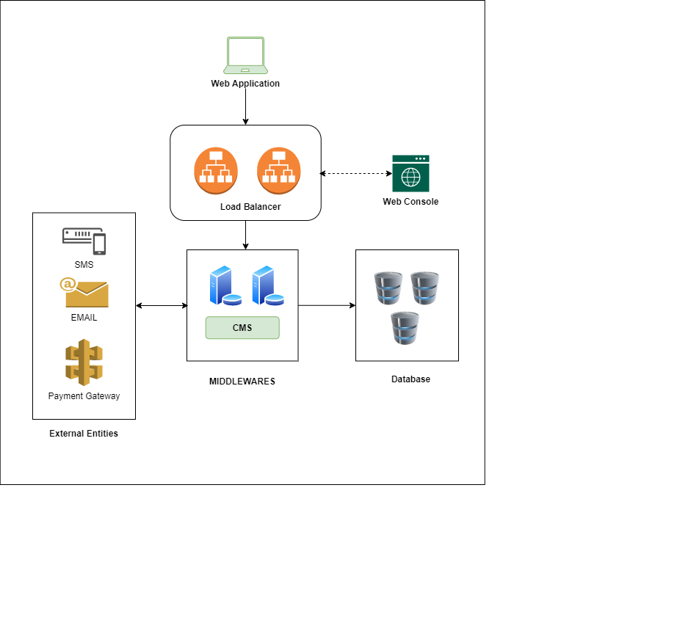

# **User Story**

## **Training Module**

### As an Admin

1. **Create Role And Permission**

**Title:** Create Role & Permission

**Priority:**

**Estimate:**

**As a** *Super Admin*

**I want to** Create Role & Permission

**So that I can** Change the Level of Access

**So that I can** maintain the Level of Access

**Acceptance criteria**

**Given**

* *Permission needs to be available*
* *There will be List screen with all Roles and assigned permission to each Role*
* *Selected Role ID information are stated*

**When** the Update Role button is clicked

**Then** the changes of the defined role are being set according to the assigned permission.

1. **Edit Role & Permission**

**Title:** Edit Role & Permission

**Priority:**

**Estimate:**

**As a** *Super Admin*

**I want to** be able to Edit Role & Permission

**I want to** be able to Edit Role & Permission

**So that I can** Change the Level of Access

**Acceptance criteria**

**Given**

* *Permission needs to be available*
* *There will be List screen with all Roles and assigned permission to each Role*
* *Selected Role ID information are stated*

**When** the Update Role button is clicked

**Then** the changes of the defined role are being set according to the assigned permission.

1. **Create User**

**Title:** Create User

**Priority:**

**Estimate:**

**As a** *Super Admin*

**I want to** Add User

**So that I can** attain the Information of the User and to Grant Accessibility

**Acceptance criteria**

**Given**

* *There will be option/field to input/type User details, Username and Password*

**When** the Create User button is clicked

**Then** the user is generated into the user list along with the specified roles.

1. **Edit User**

**Title:** Edit User

**Priority:**

**Estimate:**

**As a** *Super Admin*

**I want to** Update User Data

**So that I can** Change the User Information and Accessibility.

**Acceptance criteria**

**Given**

* *User details, Username and Password option/field are presented to input/type.*
* *User data of the selected User ID is available*

**When** the Edit User button is clicked

**Then** the updated data of the User ID is generated into the user list

1. **Create Syllabus**

**Title:** Create Syllabus

**Priority:**

**Estimate:**

**As a** *Super Admin*

**I want to** Create Syllabus

**So that I can** add subjects to a syllabus.

**Acceptance criteria**

**Given**

* *There will be section and field to create new syllabus*

**When** the Create Syllabus button is clicked

**Then** the Syllabus is generated where subjects can be created in.

1. **Edit Syllabus**

**Title:** Edit Syllabus

**Priority:**

**Estimate:**

**As a** *Super Admin*

**I want to** Edit Syllabus

**So that I can** Update Syllabus

**Acceptance criteria**

**Given**

* *Edit Syllabus option is available.*

**When** the Edit Syllabus button is clicked after making required modification

**Then** previously created syllabus will be edited.

1. **Create Subject**

**Title:** Create Subject

**Priority:**

**Estimate:**

**As a** *Super Admin*

**I want to** Create Subject

**So that I can** add subjects to specific syllabus.

**Acceptance criteria**

**Given**

* *There will be field/option for creating subject.*
* *Each subject can be made under specific curriculum, such as O level/ A level*

**When** the Create Subject button is clicked after inputting data

**Then** the Subject will be created under a specific curriculum/ syllabus.

1. **Edit Subject**

**Title:** Edit Subject

**Priority:**

**Estimate:**

**As a** *Super Admin*

**I want to** Edit Subject

**So that I can** update subject

**Acceptance criteria**

**Given**

* *There will be field/option for editing subject*
* *Edit button is available for entering editing form*

**When** the Update Subject button is clicked after editing

**Then** the changes of the subject will be made.

1. **Approval for Uploaded Contents**

**Title:** Approval for Uploads

**Priority:**

**Estimate:**

**As a** *Super Admin*

**I want to** Validate Content Uploads

**So that I can** Qualify Uploads of the Content Vault

**Acceptance criteria**

**Given**

* *All uploads of the vault are presented into vault list*

**When** the Accept button is clicked  
**Then** the upload file is being uploaded to the Content vault.

**When** the Reject button is clicked  
**Then** the upload file is being removed from the Content vault.

1. **Approval for Course**

**Title:** Approval for Course

**Priority:**

**Estimate:**

**As a** *Super Admin*

**I want to** Validate entire course.

**So that I can** Qualify appropriate course and contents for a training.

**Acceptance criteria  
Given**

* *Trainer has already published the course;*
* *The course is present in the List of All Training List*

**When** the Accept button is clicked  
**Then** the course will be available in the existing course section and will be available for all the student.

**When** the Reject button is clicked  
**Then** the requested course will be removed from training list

**When** the View Details button is clicked  
**Then** the course content will be visible to the admin.

1. **Survey Initiation**

**Title:** Initiating Survey

**Priority:**

**Estimate:**

**As a** *Super Admin*

**I want to** initiate course survey

**So that I can** execute last day of the course via taking a survey.

**Acceptance criteria  
Given**

* *Learners have participated in the course;*
* *The course is ended;*

**When** the Initiate Survey button is clicked  
**Then** the course will be available with an extra day at the end with a survey form.

1. **Survey View Details**

**Title:** View Survey Details of a Course

**Priority:**

**Estimate:**

**As a** *Super Admin*

**I want to** view survey details

**So that I can** examine which students have participated in the survey.

**Acceptance criteria  
Given**

* *Admin has already initiated the survey for a course*

**When** the View Details button is clicked  
**Then** the survey feedbacks will be available to the Admin.

### As a Trainer

1. **Upload Course Content**

**Title:** Upload course content

**Priority:**

**Estimate:**

**As a** *Trainer*

**I want to** upload course content

**So that I can** use that content from vault If I require them for designing a course.

**Acceptance criteria**

**Given**

* There is an upload button available for uploading contents from local machine.

**When** the choose files button is clicked  
**Then** the trainer is able to choose content files from local machine.

**When** the Save button is clicked  
**Then** the contents will be visible to admin’s vault management for acceptance.

1. **Create Training/ Course**

**Title:** Create Training

**Priority:**

**Estimate:**

**As a** *Trainer*

**I want to** create a Course

**So that I can** publish/save the Updated Course.

**Acceptance criteria**

**Given**

* *There is a button Create New Course available*
* *Select file option is available for Training video & cover page*
* *Trainer can determine the passing criteria for a course*
* *Trainer can also add quiz / live class to the course*

**When** the Save button is clicked  
**Then** the updated training file is being saved into draft.  
**When** the Publish button is clicked  
**Then** the updated training is being listed for acceptance by admin in Training Management.

1. **Edit Training**

**Title:** Edit Training for Draft

**Priority:**

**Estimate:**

**As a** *Trainer***I want to** edit the Course **So that I can** publish/save the Updated Course

**Acceptance criteria  
Given**

* *There will be field/option to input/type for Training Details, Overview, Schedule and Package wise Pricing*
* *Select file option is available for Training video & cover page*

**When** the Save button is clicked

**Then** the updated training file is being saved into saved courses section.

**When** the Publish button is clicked

**Then** the updated training file is being published into the vault.

1. **Create New Quiz**

**Title:** Create New Quiz

**Priority:**

**Estimate:**

**As a** *Trainer*

**I want to** create new quiz

**So that I can** incorporate that quiz with a course

**Acceptance criteria**

**Given**

* *There will be a button for Create New Quiz in My Question Page*
* *Trainer can choose to have mcq / descriptive quiz*
* *Fields for inputting questions is provided*

**When** the Save button is clicked

**Then** the quiz is saved in My Question page

1. **Evaluate Participant’s Quiz performance**

**Title:** Assess participants quiz

**Priority:**

**Estimate:**

**As a** *Trainer*

**I want to** assess participants quiz (Descriptive)

**So that I can** put proper marks against their question feedbacks

**Acceptance criteria**

**Given**

* *Participants have enrolled in that course*
* *Participants have participated the quizzes*
* *There will be a Details button available in Participants information section*

**When** the Details button is clicked

**Then** the trainer will be accessed to participants quiz grades, assignments and additional tasks information.

**When** the view link is clicked under quiz grade column against each quiz

**Then** the trainer will be able to access quiz feedback details

1. **Attendance**

**Title:** Attendance

**Priority:**

**Estimate:**

**As a** *Trainer*

**I want to** take attendance of participants

**So that I can** have attendance log of participants

**Acceptance criteria**

**Given**

* *My Activities Link is available in Trainer homepage*
* *Selecting training by dropdown is available in My Activities*
* *Alert participant button is available for taking participants attendance*

**When** the Alert Participant button is clicked

**Then** the participants will be getting a popup notification to input their attendance

1. **Conduct Online Class**

**Title:** Live Online Class

**Priority:**

**Estimate:**

**As a** *Trainer*

**I want to** conduct online live class session

**So that I can** conduct the class online

**Acceptance criteria**

**Given**

* *My Activities Link is available in Trainer homepage*
* *Selecting training/ course from dropdown is available in My Activities*
* *Start Now Button is available for starting online class*

**When** the Start Now button is clicked

**Then** Trainer will be able to get in and initiate the live class session on Zoom.

1. **Generate Certificate**

**Title:** Generate Certificate

**Priority:**

**Estimate:**

**As a** *Trainer*

**I want to** publish certificates

**So that I can** publish certificates to the competent students

**Acceptance criteria**

**Given**

* *My Activities Link is available in Trainer homepage*
* *Selecting training by dropdown is available in My Activities*
* *Participants have completed entire course*
* *Participants have attended final survey initiated by Admin*
* *Generate Certificate Button is available*

**When** the Generate Certificate button is clicked

**Then** Certificates will be available to the competent students in their achievement section

### As a Participant

1. **Profile Completion**

**Title:** Profile Completion

**Priority:**

**Estimate:**

**As a** *Participant*

**I want to** Complete My Profile

**So that I can** enroll in courses

**Acceptance criteria**

**Given**

* *Finish your profile button is available in participant’s homepage*
* *Information fields are available for personal, education, training, employment, photo*

**When** the Update button is clicked for each section

**Then** participants will be able to update information to the latest

1. **Enroll in a Course**

**Title:** Enroll in a Course

**Priority:**

**Estimate:**

**As a** *Participant*

**I want to** enroll in a course

**So that I can** participate in that course

**Acceptance criteria**

**Given**

* *Available course section is available in participants homepage*
* *Courses made by trainers are available in the sections of available courses/upcoming courses*
* *Enroll now button is available in a course’s description page*

**When** the Enroll Now Button is clicked

**Then** participants will be able to enroll in that course if the participant’s profile is completed for more than or equal to 60%.

1. **Wishlist**

**Title:** Wishlist

**Priority:**

**Estimate:**

**As a** *Participant*

**I want to** keep courses in Wishlist

**So that I can** refer to those courses later on, as my convenience

**Acceptance criteria**

**Given**

* *Available course section is available in participants homepage*
* *Courses made by trainers are available in the sections of available courses/upcoming courses*
* *Wishlist button is available in a course’s description page*

**When** the Wishlist Button is clicked

**Then** the course will be saved in Wishlist page

1. **Start Training/ Course**

**Title:** Conduct Training/ Course

**Priority:**

**Estimate:**

**As a** *Participant*

**I want to** start training/ Course

**So that I can** perform classes in regarded training

**Acceptance criteria**

**Given**

* *Participants have enrolled in a course*
* *My courses page is available*
* *Start Training button is available for each course*

**When** the Start Training Button is clicked

**Then** participants will be able to access course contents

1. **Join Live Class**

**Title:** Join Live Class

**Priority:**

**Estimate:**

**As a** *Participant*

**I want to** join in a live class

**So that I can** attend live class

**Acceptance criteria**

**Given**

* *Join Now Button is available*

**When** the Join Now Button is clicked

**Then** participants will be accessed to live class session

1. **Attend Quiz**

**Title:** Attend Quiz

**Priority:**

**Estimate:**

**As a** *Participant*

**I want to** attend quiz

**So that I can** attend mcq/descriptive quiz

**Acceptance criteria**

**Given**

* *Start Now button is available*

**When** the Start Now Button is clicked

**Then** participants will be accessed to attend a quiz.

1. **Attend Survey**

**Title:** Attend Survey

**Priority:**

**Estimate:**

**As a** *Participant*

**I want to** attend survey

**So that I can** entirely complete the course and get validated for course certificate

**Acceptance criteria**

**Given**

* *Admin has initiated survey*
* *Survey Question has appeared as last day of the course*

**When** survey question are submitted

**Then** competentparticipants will be awarded with course certificate

1. **View Certificate**

**Title:** View Certificate

**Priority:**

**Estimate:**

**As a** *Participant*

**I want to** view my certificate

**So that I can** collect/view/download my certificate

**Acceptance criteria**

**Given**

* *Participant has completed survey question*
* *There’s an Achievements page*
* *Participant has met passing cut off marks*
* *View Certificate option*

**When** the View Certificate is clicked

**Then** participants will be accessed to their certificates

1. **Add Certificates to LinkedIn**

**Title:** Add Certificates to LinkedIn

**Priority:**

**Estimate:**

**As a** *Participant*

**I want to** share my certificate in LinkedIn

**So that I can** Share my certificate

**Acceptance criteria**

**Given**

* *Add to LinkedIn button is available*

**When** the Add to LinkedIn Button is clicked

**Then** participants will be able to share their certificates in LinkedIn

## **Assessment Module**

### As an Admin

1. **Create Skills**

**Title:** Create Skills

**Priority:**

**Estimate:**

**As an** *Admin*

**I want to** Create Skills

**So that I can** make skills available for trainers to make assessment

**So that I can** maintain the Level of Access

**Acceptance criteria**

**Given**

* *Permission needs to be available*

**When** the Create Button is clicked with keeping the status active

**Then** the skill will be created and it will be available for the trainers to use

1. **Edit Skill**

**Title:** Edit Role & Permission

**Priority:**

**Estimate:**

**As an** *Admin*

**I want to** be able to edit skill.

**So that I can** edit existing skills.

**So that I can** Change the Level of Access

**Acceptance criteria**

**Given**

* *Permission needs to be available*

**When** the Update button is clicked

**Then** the changes will be made.

1. **Create Content Source**

**Title:** Create Content Source

**Priority:**

**Estimate:**

**As an** *Admin*

**I want to** Create Content Source

**So that I can** provide trainers with content source list to add to their improvement plans while creating.

**Acceptance criteria**

**Given**

* *Admin permission is available;*
* *Source Information page with Create New button is available;*

**When** the Create Button is clicked with keeping the status active

**Then** the source will be created and it will be available for the trainers to use

1. **Edit Content Source**

**Title:** Edit Content Source

**Priority:**

**Estimate:**

**As an** *Admin*

**I want to** Edit Content Source

**So that I can** edit existing source listed in Source Information page;

**Acceptance criteria**

**Given**

* *Admin permission is available;*
* *Edit button under Action column in Source Information page is available;*

**When** the Update button is clicked

**Then** the changes will be made.

1. **Set Improvement Plan**

**Title:** Set Improvement Plan

**Priority:**

**Estimate:**

**As an** *Admin*

**I want to** Set Improvement Plan

**So that I can** update and set improvement plans for individuals with different combinations of experience level and Improvement level.

**Acceptance criteria**

**Given**

* *Update option is available with all the different combinations of experience level and improvement level.*
* *Dropdown for selecting improvement plan from available list is present*

**When** the Update button is clicked

**Then** improvement plan will be set to targeted individuals.

1. **Time Extension Request**

**Title:** Time Extension Request

**Priority:**

**Estimate:**

**As an** *Admin*

**I want to** Accept or Reject Improvement Plan Time Requests

**So that I can** decide who would get time extension and who would not.

**Acceptance criteria**

**Given**

* *Permission available*
* *Request accept and reject buttons are available*

**When** the Accept button is clicked**Then** time extension request will be approved

**When** the Reject button is clicked**Then** time extension request will be denied

1. **Improvement Plan Status**

**Title:** Improvement Plan Status

**Priority:**

**Estimate:**

**As an** *Admin*

**I want to** view participants improvement status

**So that I can** view participants improvement status and based on that decide whose improvement plan time should be extended.

**Acceptance criteria**

**Given**

* *Permission available;*
* *List of participants having improvement plan is visible;*
* *Extend Time Button is available;*

**When** Extend Time button is clicked**Then** screen for time extension will appear;

1. **Signatory Info**

**Title:** Create New Signatory

**Priority:**

**Estimate:**

**As an** *Admin*

**I want to** Create New Signatory

**So that I can** Add new signatory available in the system for trainers to use.

**Acceptance criteria**

**Given**

* *Permission required*
* *Signatory page is created with Create new option*

**When** the Create button is clicked with all the required data

**Then** a signatory will be added to the DB.

### As a Trainer

1. **Certificate Signatory**

**Title:** Add Signatory

**Priority:**

**Estimate:**

**As a** *Trainer*

**I want to** Add Signatory of Certificate Issuer

**So that** Signatories appear in Certificate

**Acceptance criteria**

**Given**

* *Dropdowns for adding signatory available in course builder*

**When** Signatories are selected and updated  
**Then** certificates will appear with issuer signatory.

1. **Create New Question**

**Title:** Create New Question

**Priority:**

**Estimate:**

**As a** *Trainer***I want to** create new question **So that I can** incorporate questions in making assessments

**Acceptance criteria  
Given**

* *Question page is available*
* *Create New Button available*
* *Skills are made by admin*
* *Question Bulk Upload option is available*

**When** soft skill type radio button is selected   
**Then** trainer can select skills from psychometric skills list

**When** job type radio button is selected   
**Then** trainer can select from existing categories.

**When** toggle button clicked to active   
**Then** question will be available to make assessments

**When** required inputs are provided and saved   
**Then** question will be listed in the question list.

1. **Create Assessment**

**Title:** Create Assessment

**Priority:**

**Estimate:**

**As a** *Trainer*

**I want to** create assessment

**So that I can** add assessment to the system for participants.

**Acceptance criteria**

**Given**

* *Assessment Information page is available*
* *Create New Button available*
* *Skills and Questions are premade*

**When** Initial type is selected  
**Then** assessment will be made under initial type

**When** Regular type is selected  
**Then** assessment will be made under regular type

**When** required inputs are provided and saved   
**Then** assessment will be saved.

1. **Improvement Plan**

**Title:** Create Improvement Plan

**Priority:**

**Estimate:**

**As a** *Trainer*

**I want to** create Improvement Plan

**So that** participants can avail improvement plan if it requires

**Acceptance criteria**

**Given**

* *Improvement Information page is available*
* *Create New Button available*

**When** required inputs are provided and saved   
**Then** improvement plan will be available to admin to update accordingly.

### As a Participant

1. **Initial Assessment**

**Title:** Initiate Initial Assessment

**Priority:**

**Estimate:**

**As a** *Participant*

**I want to** access Initial Assessment

**So that I can** sit for assessment test.

**Acceptance criteria**

**Given**

* *Participant profile is completed till 60% or above*
* *Skill assessment section is available*

**When** start now button of initial assessment is clicked  
**Then** Assessment will begin.

1. **Regular Assessment**

**Title:** Initiate Regular Assessment

**Priority:**

**Estimate:**

**As a** *Participant*

**I want to** access Regular Assessment

**So that I can** sit for assessment test.

**Acceptance criteria**

**Given**

* *Participant profile is completed till 60% or above*
* *Initial Assessment is completed*
* *Skill assessment section is available*

**When** start now button of Regular assessment is clicked  
**Then** Assessment will begin.

1. **Improvement Plan**

**Title:** Join Improvement Plan

**Priority:**

**Estimate:**

**As a** *Participant*

**I want to** access improvement plan.

**So that I can** pass improvement plan and unlock regular assessment.

**Acceptance criteria**

**Given**

* *Participant profile is completed till 60% or above*
* *Skill assessment section is available*
* *Participant has failed in initial assessment*

**When** Improve now button is clicked  
**Then** System redirects to improvement plan page

1. **Complete Improvement Plan**

**Title:** Complete Improvement Plan

**Priority:**

**Estimate:**

**As a** *Participant*

**I want to** complete improvement plan.

**So that I can** pass improvement plan and unlock regular assessment.

**Acceptance criteria**

**Given**

* *Participant profile is completed till 60% or above*
* *Skill assessment section is available*
* *Participant has failed in initial assessment*

**When** all the tutorials are marked as finished in improvement plan  
**Then** Results will show pass for that improvement plan.

1. **Time Extension Request for Improvement Plan**

**Title:** Time Extension Request

**Priority:**

**Estimate:**

**As a** *Participant*

**I want to** request for time extension for improvement plan

**So that I can** get a time extension to complete improvement plan

**Acceptance criteria**

**Given**

* *Initial assessment is completed;*
* *Time Extension limit dropdown is available;*
* *Send Request button is available;*

**When** time extension limit is chosen from dropdown and clicked on Send Request button  
**Then** Admin will get Improvement Plan Time Extension request.

1. **View Assessment Results**

**Title:** View Assessment Results

**Priority:**

**Estimate:**

**As a** *Participant*

**I want to** access assessment results.

**So that I can** see my results.

**Acceptance criteria**

**Given**

* *Participant has appeared in initial or regular assessment*

**When** assessments section in achievement page is accessed   
**Then** participant will be able to see his/her assessment results.

# **Solution Process Flow**

## Training Module

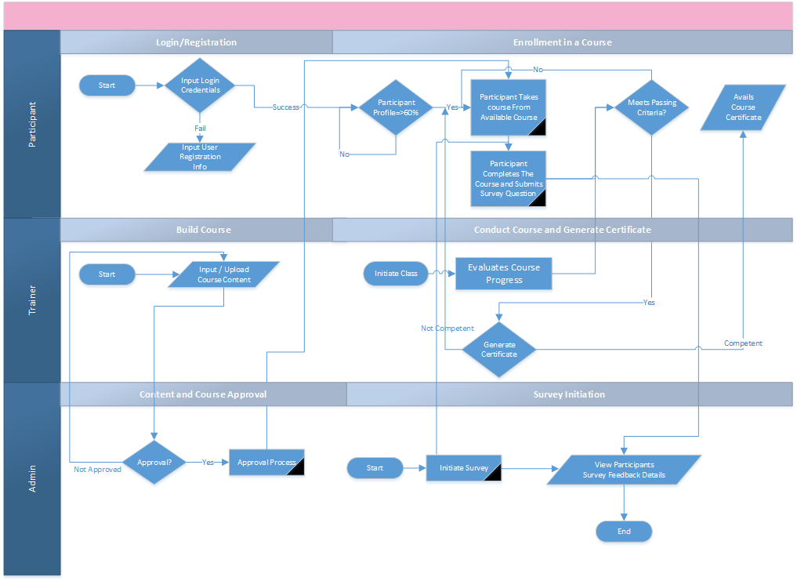

## Assessment Module

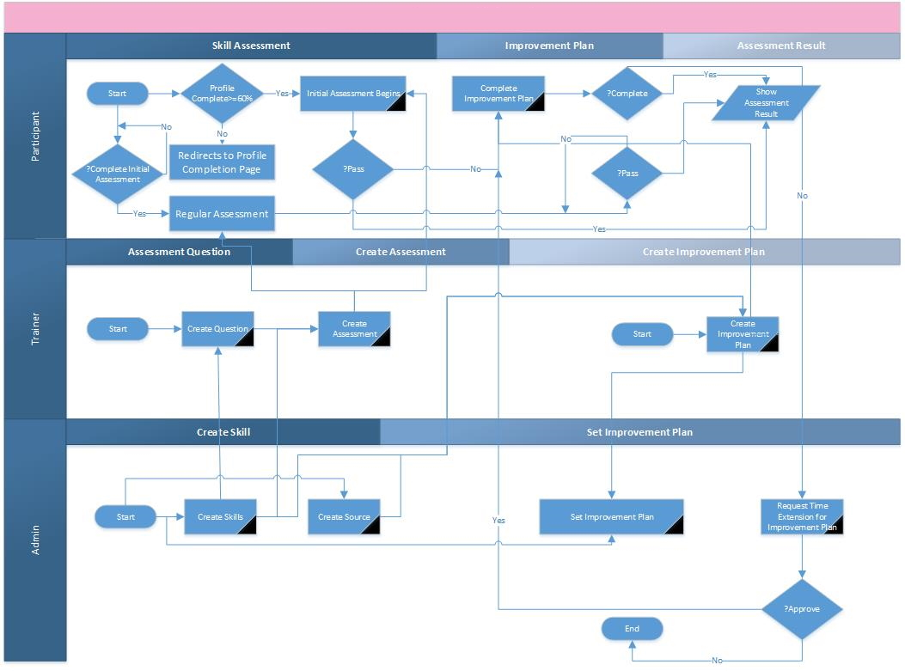

# **Proposed Team Members**

|  |  |
| --- | --- |
| **Designation** | **Head of Business Operations** |
| Years of experience | 16 years + |
| Technology | IT Systems, Security, Architecture, Telecom Infrastructure, Datacom, Project Managment, Product Management |
| Degree | B.Sc. (Hons)/ M.Sc. in Computer Science |
| Short Description | 15 + years in diversified fields of ICT as Software Developer, Technical Writer, Systems Analyst and Project Manager. Developed in-depth knowledge on Software development life cycle, help documentations & white papers for software developers. Recognized for translating technical information into easy to understand English. Committed to collaborate with Clients & Software development team in order to maintain smooth communication & also to provide defect free solutions. |

|  |  |
| --- | --- |
| **Designation** | **Senior System Analyst** |
| Years of experience | 10 years + |
| Database | Microsoft SQL Server 2000 to 2016, MSSQL DB Clustering, Oracle 10g, MySQL, Project |
| Reporting Tools | Microsoft BI (SSRS, SSIS), QlikView, Crystal Reports. |
| Language | PL/SQL, Database Programming |
| Degree | B.Sc. in CSE |
| Short Description | Worked on System Analysis and Design, Requirements analysis as well as ensure the synchronization of business process and system development in Renowned Groups, IT Enabled Firms. Developed interactive dashboards and reports in different Business Intelligence tools. Also worked in several RDBMS including DB programming and Administration. |

|  |  |
| --- | --- |
| **Designation** | **Senior Software Developer** |
| Years of experience | 10 years + |
| Language | PhP, ASP .NET |
| Scripting language | node js, Vue js, JavaScript, jquery |
| Database | Sql Server 2008, 2014, Oracle 10g, 12c, MySQL |
| Version control tool | TortoiseSVN, Git, TFS |
| Degree | M.Sc. in IT |
| Short Description | 10+ years of software development experience. Currently working as a Senior software engineer. Have more than 7 years of diversified experience in the field of ICT. Worked for Renowned ICT industry in Bangladesh. Extensive knowledge on Enterprise Appications, ERP, CRM System, Telecom Billing Solution. |

|  |  |
| --- | --- |
| **Designation** | **Software Engineer** |
| Years of experience | 3 Years+ |
| Technology | PHP- Laravel, React JS, Python |
| Degree | B.Sc. in CSE |
| Short Description | 3+ years of full stack application development experience. |

|  |  |
| --- | --- |
| **Designation** | **Software Engineer** |
| Years of experience | 4 Years+ |
| Technology | PHP- Laravel, React JS, Python |
| Degree | B.Sc. in CSE |
| Short Description | 4+ years of full stack application development experience. |

|  |  |
| --- | --- |
| **Designation** | **Software Engineer** |
| Years of experience | 4 years + |
| Technology | PHP- Laravel, React JS, Vue JS, Python, Wordpress |
| Degree | B.Sc. in CSE |
| Short Description | 4+ years of application development experience. |

|  |  |
| --- | --- |
| **Designation** | **Junior Software Engineer** |
| Years of experience | 2 years + |
| Technology | PHP- Laravel, React JS, Python |
| Degree | B.Sc. in CSE |
| Short Description | 3+ years of application development experience. |

|  |  |
| --- | --- |
| **Designation** | **Head of Infrastructure** |
| Years of experience | 12 years + |
| Technology | IT Systems, Security, Architecture, Telecom Infrastructure, Datacom. |
| Degree | B.Sc. in CSE |
| Training | Cyber Security Concepts & Principles  RHCSA and RHCE  CCNA |
| Short Description | 12+ years of core IT, infrastructure and cyber security systems experience. |

|  |  |
| --- | --- |
| **Designation** | **Project Manager (Technical)** |
| Years of experience | 6 years + |
| Technology | Planning and forecasting, Risk management, Budgeting, Tracking and monitoring, Project management methodologies (Agile, Waterfall, Kanban, etc.), Meeting facilitation, Subject matter expertise, Project management software (Jira, Trello, Asana, etc.). |
| Degree | BSc in CSE |
| Short Description | Experienced Project Manager with a demonstrated history of working in the Software Industry. |

|  |  |
| --- | --- |
| **Designation** | **Sr. Executive, IT Services** |
| Years of experience | 7 years + |
| Technology | IT Systems, Security, Architecture, Telecom Infrastructure, Datacom. |
| Degree | B.Sc. in CSE |
| Short Description | 7+ years of core IT, infrastructure and cyber security systems experience. |

|  |  |
| --- | --- |
| **Designation** | **UI/UX Expert** |
| Years of experience | 6 years + |
| Technology | UI, UX, Mock-up and prototype development. |
| Degree | MSC in ICT |
| Short Description | 6+ years of application UI/UX development experience. |

|  |  |
| --- | --- |
| **Designation** | **Junior Business Analsyt** |
| Years of experience | 2 years+ |
| Specialization | * Documentation-SRS, BRS, PRD, User Story, User Manual, Technical Proposal, Business Plan, Test Report, Bug Report, RTM; * Software Process Diagramming: Activity Diagram, Sequence Diagram, DFD, Use Case Diagram, Class Diagram; * Solution Demonstration; * Software Quality Assuarance. |
| Degree | B.Sc. in Computer Science |
| Short Description | 2 years+ experience in fields of Product Analysis, IT Business Analysis, Software Testing and Quality Assuarance. |

|  |  |
| --- | --- |
| **Designation** | **Tester & QA** |
| Years of experience | 3 years + |
| Technology | Testing, QA & documentation |
| Degree | BSc in CSE |
| Short Description | 3+ years of application UI/UX development experience. |